Beginner Guide to Python Visualization Libraries: Matplotlib vs Seaborn

# 1. Introduction

This guide introduces two powerful Python visualization libraries: Matplotlib and Seaborn. Both libraries enable users to generate various types of plots and charts with ease, but they differ in functionality, complexity, and visual appeal. This document highlights the differences, provides examples, and shows visual output for each graph type.

# 2. Library Overview

## Matplotlib

Matplotlib is a foundational plotting library in Python that offers fine-grained control over every aspect of a figure. It is ideal for creating static, animated, and interactive plots in Python.

## Seaborn

Seaborn is built on top of Matplotlib and provides a high-level interface for drawing attractive and informative statistical graphics. It works well with Pandas DataFrames and includes support for themes, color palettes, and more.

# 3. Graph Types and Examples

## Line Plot

Line plots are useful for visualizing trends over a continuous interval or time span.  
  
Matplotlib Code:  
x = [1, 2, 3, 4]  
y = [10, 20, 25, 30]  
plt.plot(x, y, marker='o')  
plt.show()

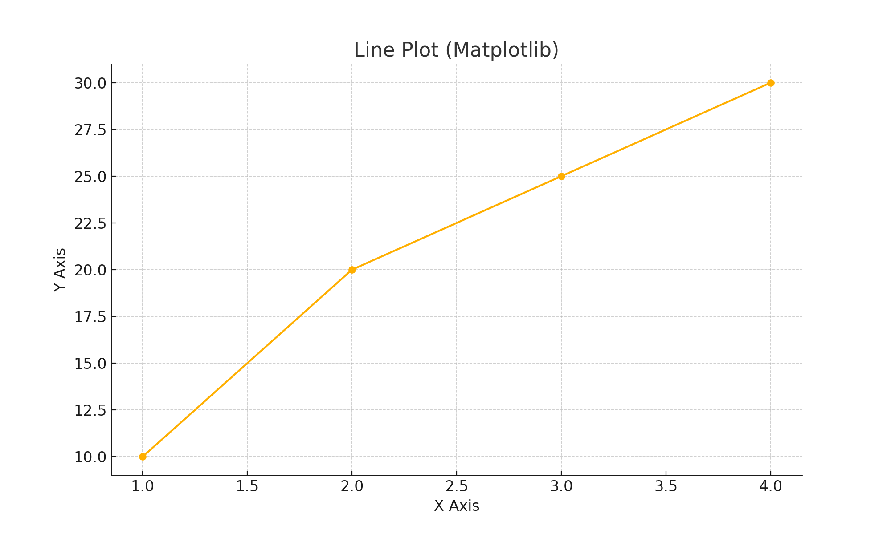

## Bar Chart

Bar charts display categorical data with rectangular bars. They are ideal for comparing quantities across categories.  
  
Matplotlib Code:  
categories = ['Math', 'Science', 'History']  
values = [85, 90, 70]  
plt.bar(categories, values)  
plt.show()

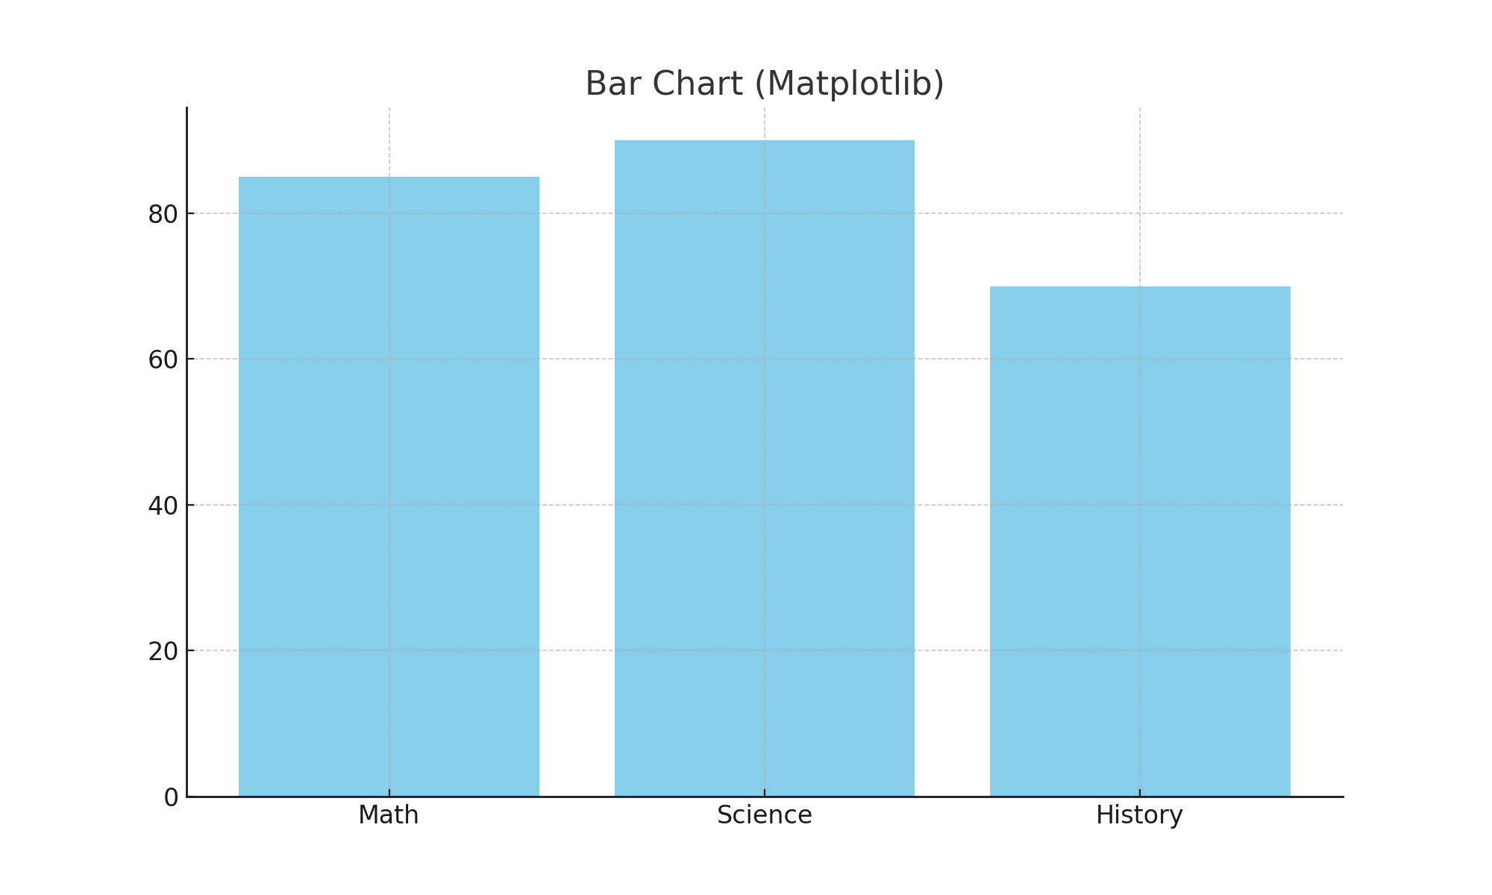

## Histogram

Histograms are used to show the distribution of a dataset. They group data into bins and count the number of observations in each.  
  
Matplotlib Code:  
data = np.random.randn(1000)  
plt.hist(data, bins=30)  
plt.show()

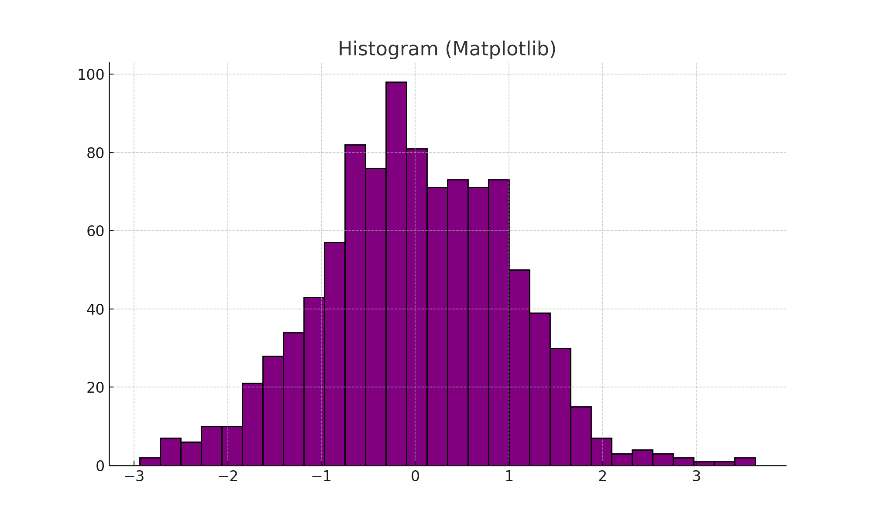

## Scatter Plot

Scatter plots show relationships between two numeric variables. Each point represents an observation.  
  
Matplotlib Code:  
x = [5, 7, 8, 7]  
y = [99, 86, 87, 88]  
plt.scatter(x, y)  
plt.show()

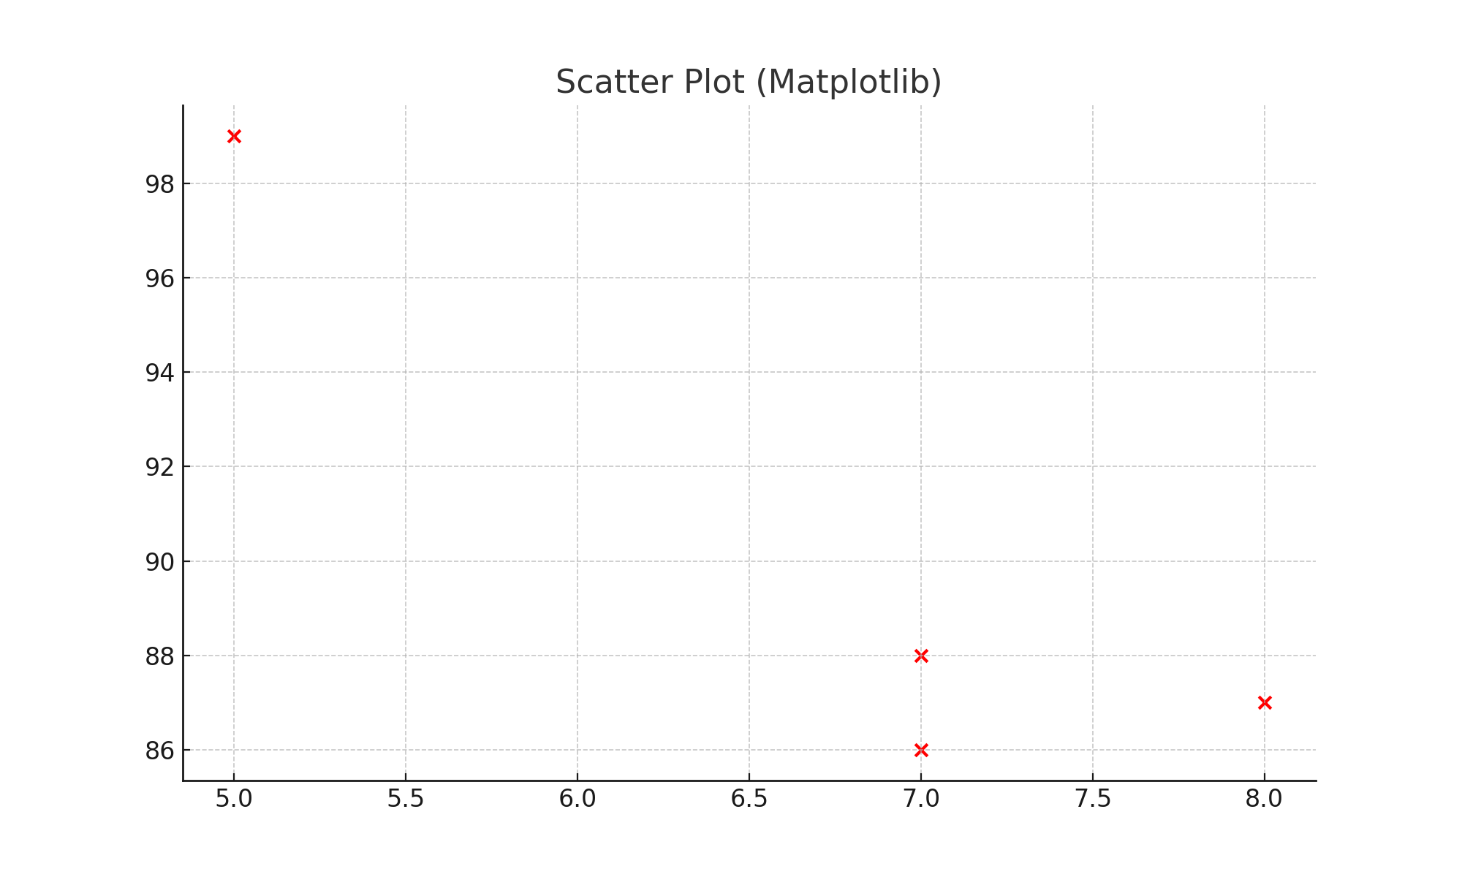

## Pie Chart

Pie charts display proportions of a whole across different categories.  
  
Matplotlib Code:  
labels = ['Python', 'Java', 'C++']  
sizes = [215, 130, 245]  
plt.pie(sizes, labels=labels)  
plt.show()

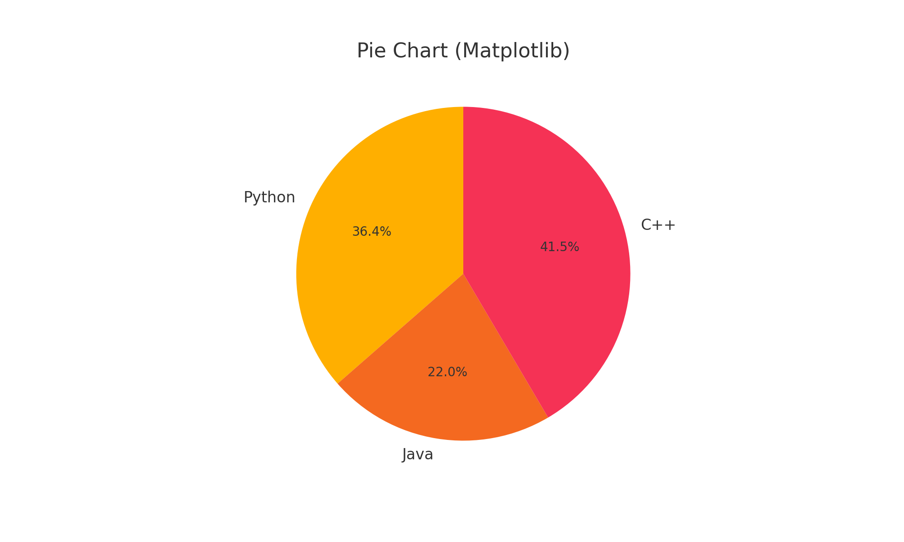

# 4. Comparison Between Matplotlib and Seaborn

Matplotlib provides more customization options and is well-suited for users who want full control over plot elements. However, it often requires more code to achieve visually appealing results.  
  
Seaborn, on the other hand, is easier to use for creating statistical plots and integrates smoothly with Pandas. It provides better default aesthetics and enables complex plots with minimal code.